**GLOBAL TERRORISM DATA VISUALIZATION USING POWERBI**

**1. Geospatial Analysis of Attacks**

This visualization provides a geospatial perspective on terrorist attacks.

* **Map Visualization**:
  + **Latitude and Longitude**: Used to plot the precise locations of attacks.
  + **Bubble Size**: Represents the number of casualties. Larger bubbles indicate higher casualties, offering a clear representation of the severity of attacks.

**Columns Used**:

* latitude: Latitude of the attack location.
* longitude: Longitude of the attack location.
* Total Casualties: Calculated as nkill + nwound (fatalities + injuries).

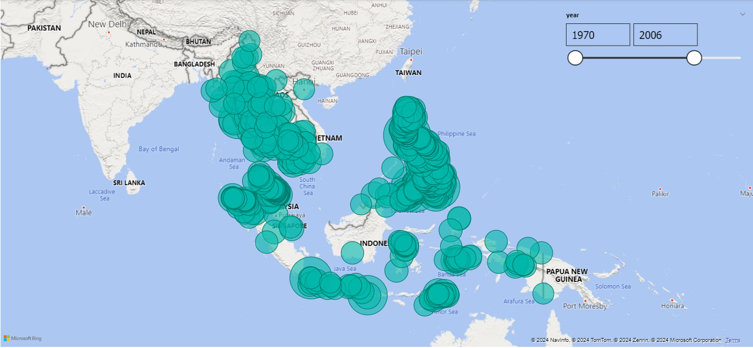

* **Slicers**:
  + **Year Filter**: Allows users to filter the map to display attacks for specific years.
  + **Region Filter**: Enables filtering of attacks based on regions, providing insights into geographical trends

**Columns Used**

* + - iyear: Year of the attack (used for the Year slicer).
    - region_txt: Name of the region (used for the Region slicer).

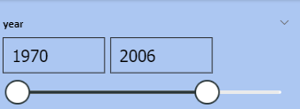

**2. Terrorist Group Comparison**

This visualization offers a comparative analysis of terrorist groups based on their activities and impact.

* **Multi-Row Card**:
  + **Metrics**:
    - **Total Attacks**: Total number of attacks carried out by each terrorist group.
    - **Total Casualties**: Summation of fatalities and injuries caused by the group's attacks.
    - **Success Rate**: Percentage of successful attacks.
  + Displays the **top 5 terrorist groups** based on the selected metric.

**Columns Used**:

* gname: Terrorist group name.
* Total Attacks: Count of attacks carried out by the group.
* Total Casualties: Summation of fatalities and injuries caused by the group's attacks.
* Success Rate: Calculated as the percentage of successful attacks using success.

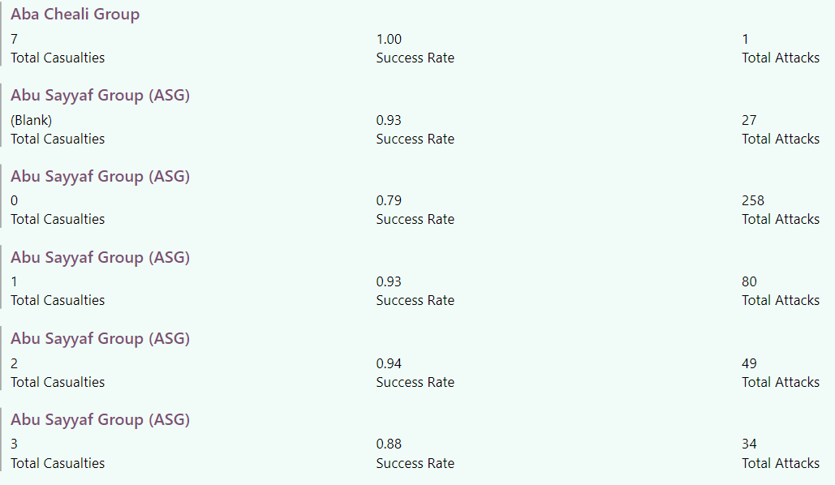

**Timeline Slicer**:

* + Allows users to explore the changes in attacks, casualties, and success rate over different years.
* **Columns Used**:

iyear: Year of the attack.

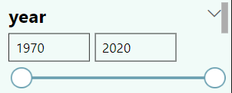

**3. Weapon Type Analysis**

This visualization focuses on the lethality of different weapon types used in attacks.

* **Treemap**:
  + **Weapon Types**: Represents weapon categories visually in proportion to their frequency of use or lethality.
  + **Color Intensity**: Indicates the lethality of weapon types:
    - Lighter colors for lower casualty numbers.
    - Darker, intense colors for higher casualty numbers.

**Columns Used**:

* weaptype1_txt: Name of the primary weapon type.
* Total Casualties: Summation of fatalities and injuries caused by each weapon type.

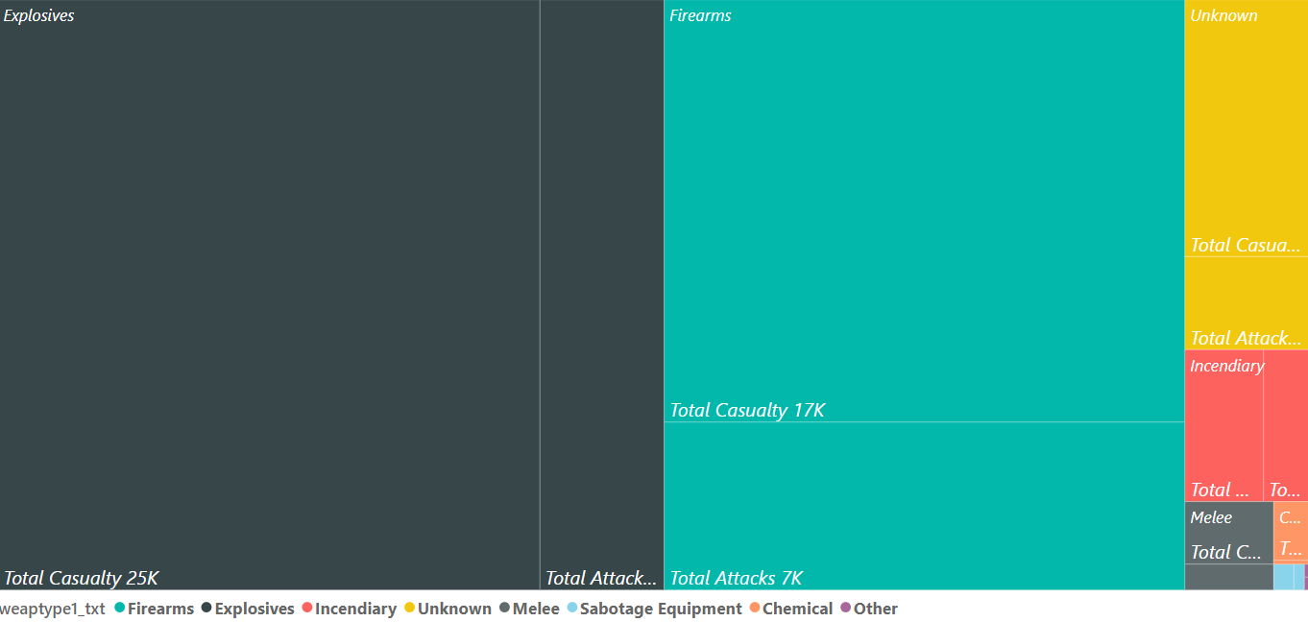

**Drill-Down Functionality**:

* + Enables users to explore **weapon subtypes** for a deeper understanding of the specific methods used in attacks.

**Columns Used**:

* weapsubtype1_txt: Name of the weapon subtype.

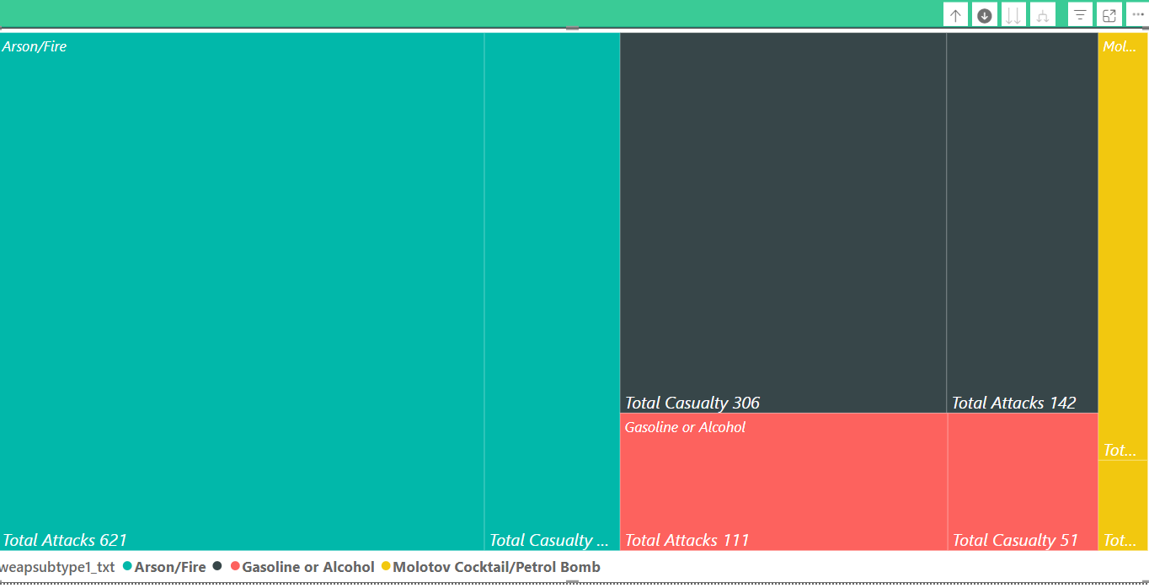

**4. Target Analysis Dashboard**

This dashboard provides insights into the types of targets attacked and their impact.

**Donut Chart**: Displays the distribution of target types in terrorist attacks, offering a quick glance at the most targeted categories.

**Columns Used**:

* targtype1_txt: Name of the primary target type.

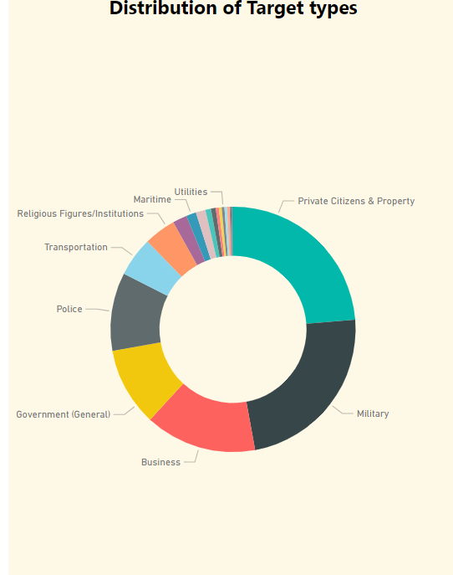

**Clustered Column Chart**: Compares casualties (fatalities and injuries) across different target types, highlighting the severity of attacks on each category.

**Columns Used**:

* targtype1_txt: Name of the primary target type (X-axis).
* Total Casualties: Summation of fatalities and injuries (Y-axis).

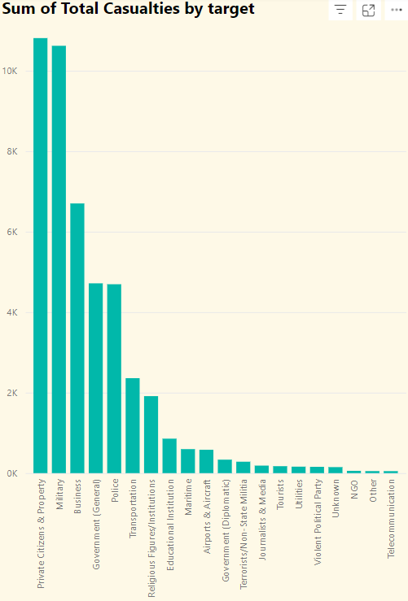

**Table**: Lists the most frequently attacked specific targets, sorted to prioritize high-frequency entries for clarity.

**Columns Used**:

* target1: Specific target attacked.
* Event Count: Count of events involving the specific target.

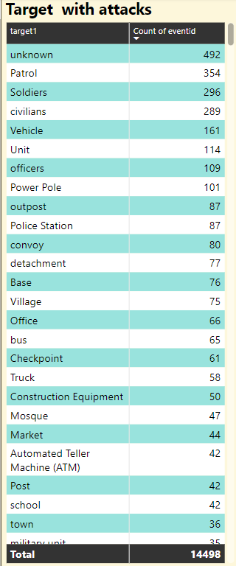

* **Bookmark Functionality**:
  + Allows users to switch between views (e.g., Donut Chart only, All Charts, Table only).

